TEST SCENARIO NO 1:VERIFY LOGIN WITH VALID CREADENTIALS
TEST ID : TC_001
TEST STEPS :ENTER THE VALID USERNAME AND PASSWARD
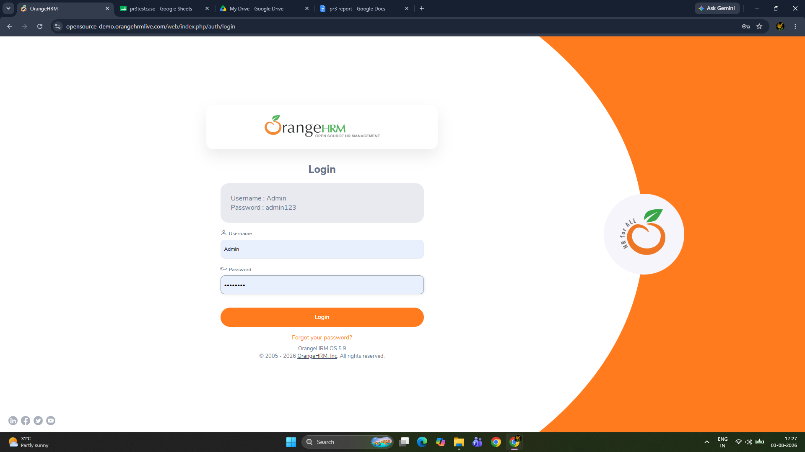

SCENAERIO 02 : VERIFY INVALID PASSWARD
TEST IID : TC_002
TEST STEPS: ENTER THE USERNAME WITH INVALID PASSWARDS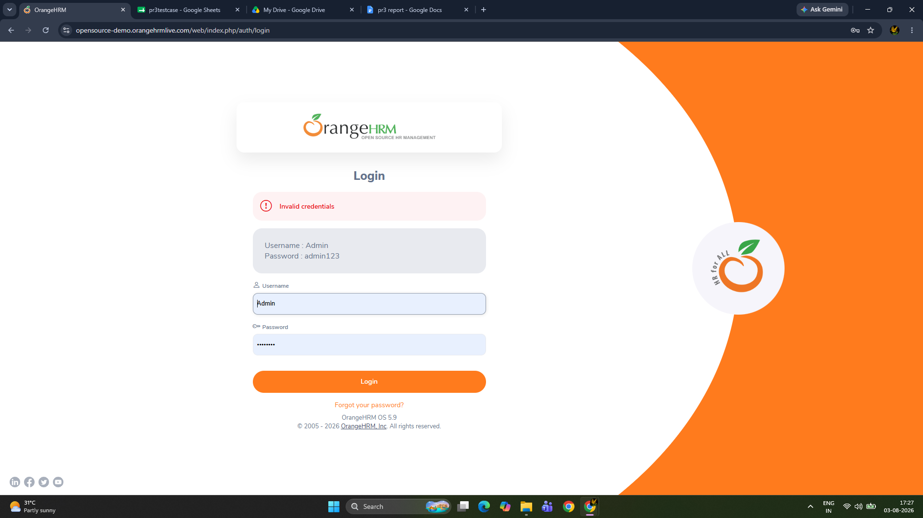
SCENAERIO 03 : VERIFY INVALID USERNAME
TEST IID : TC_003
TEST STEPS: ENTER THE INVALID USERNAME WITH VALID PASSWARDS
SCENAERIO 03 : VERIFY EMPTY USERNAME
TEST IID : TC_003
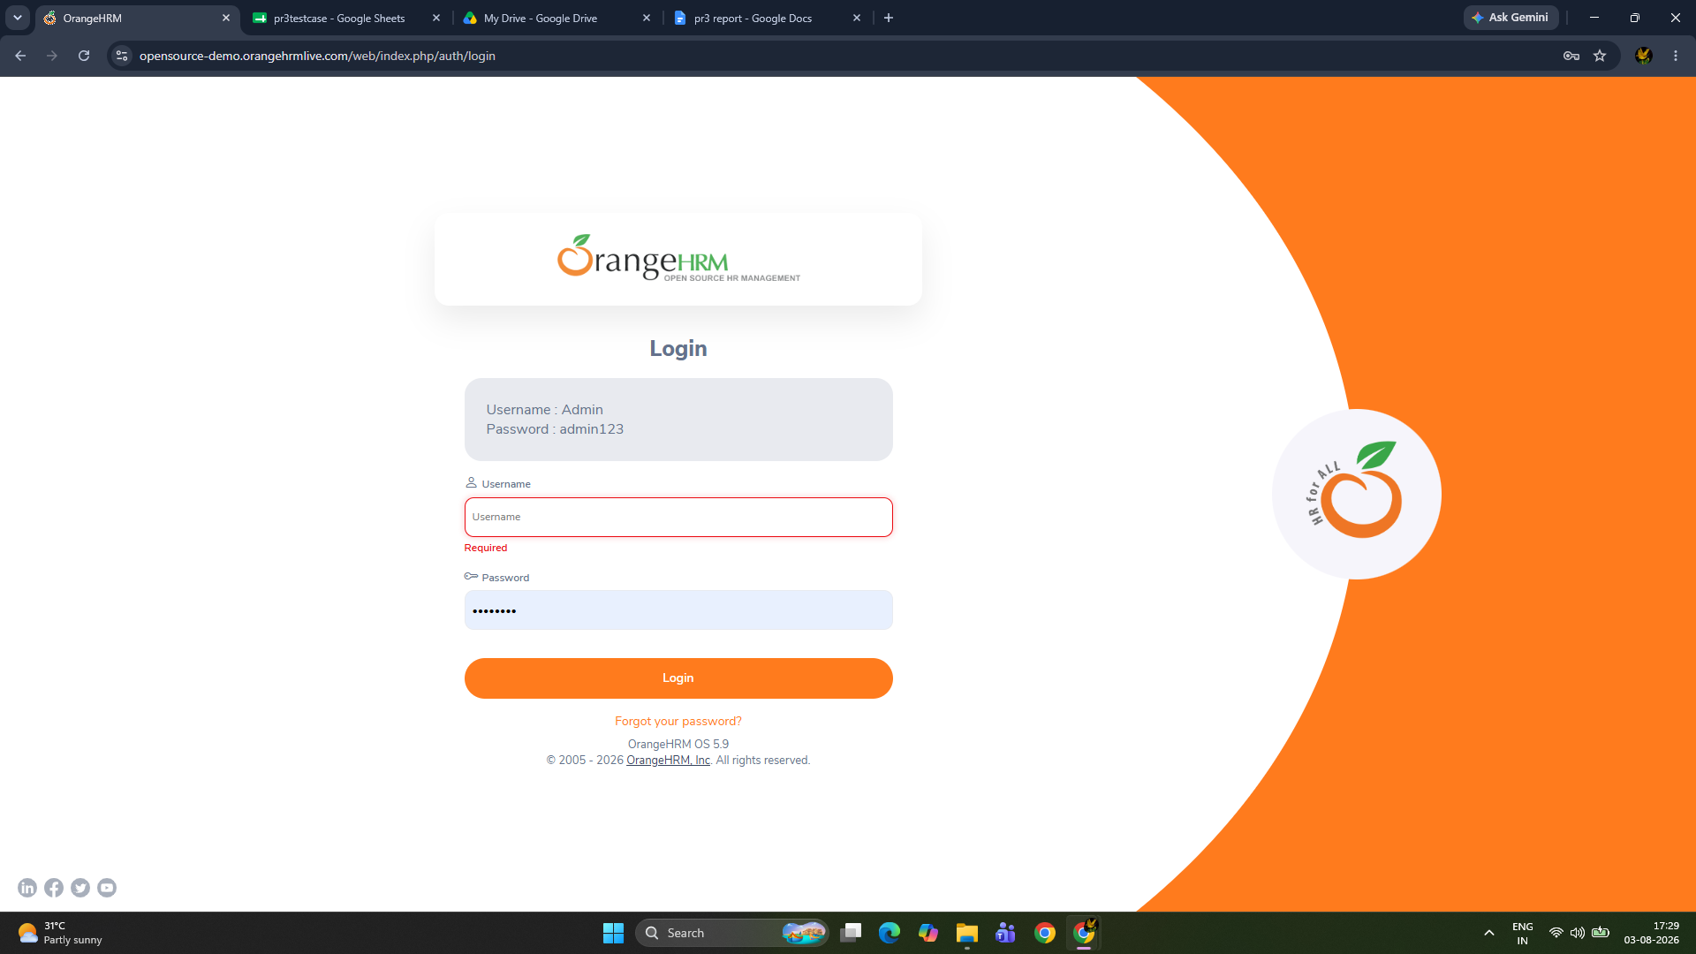
TEST STEPS: ENTER THE PASSWARD ONLY
SCENAERIO 04 : VERIFY EMPTY PASSWARD
TEST IID : TC_004
TEST STEPS: ENTER THE USERNAME ONLY 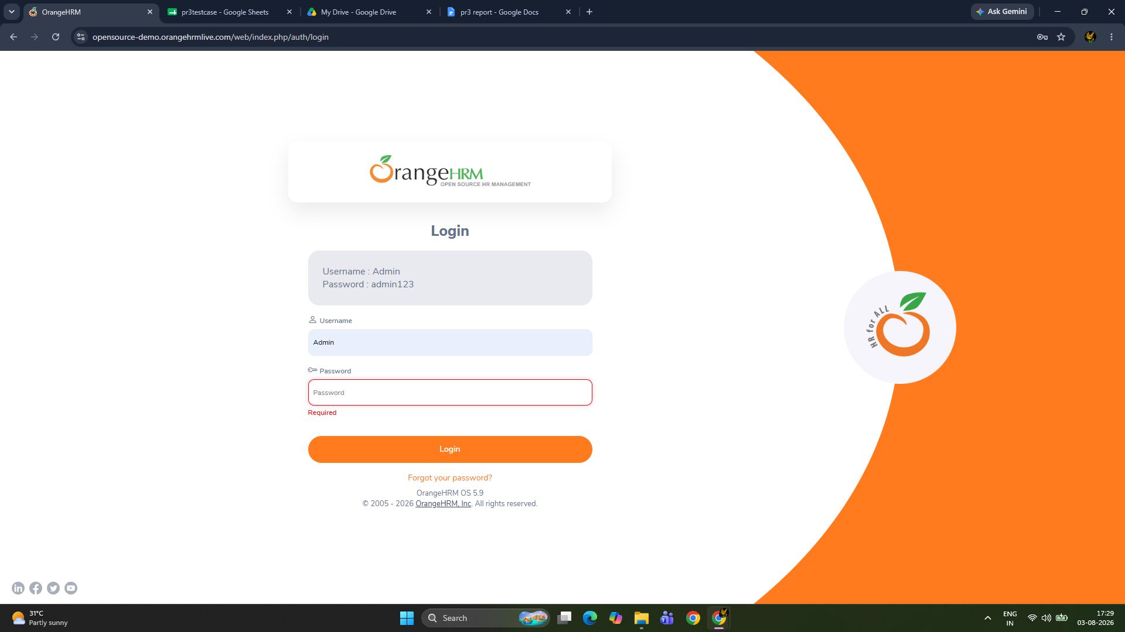

SCENAERIO 05 : VERIFY BOTH EMPTY FILED
TEST IID : TC_005
TEST STEPS:BLANK BOTH FIELD 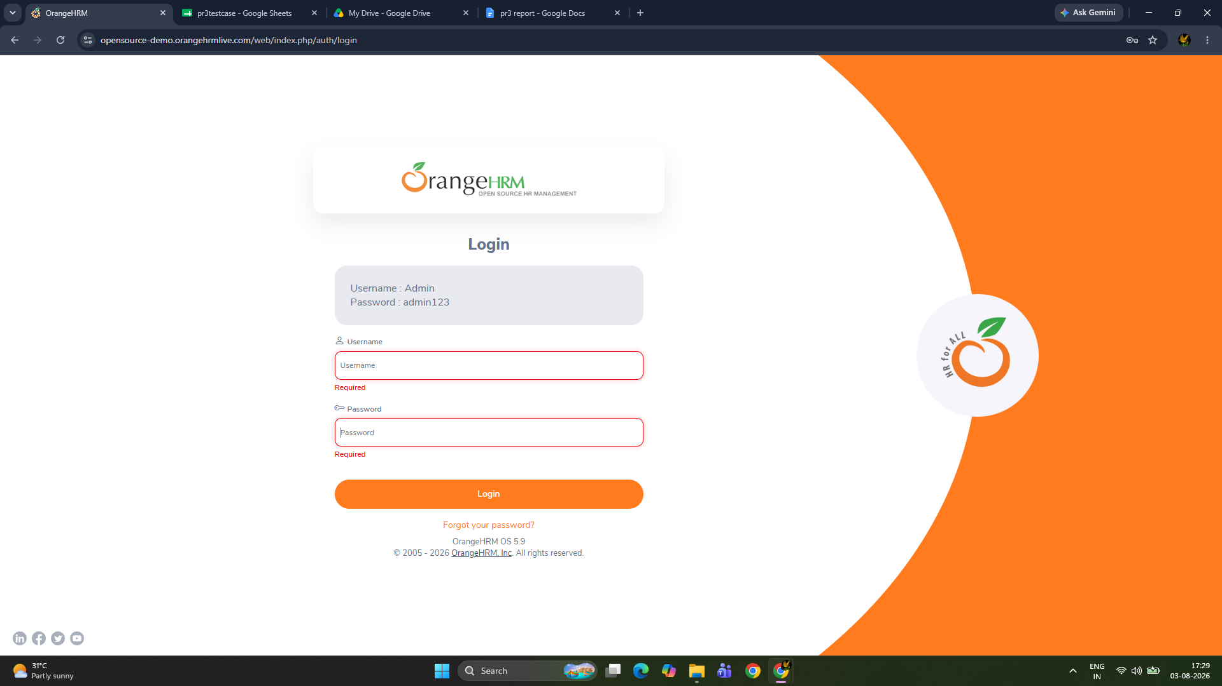
SCENAERIO 06 : VERIFY FORGOT PASSWARD LINK
TEST IID : TC_006
TEST STEPS: CLICK TO FORGOT PASSWARD LINK 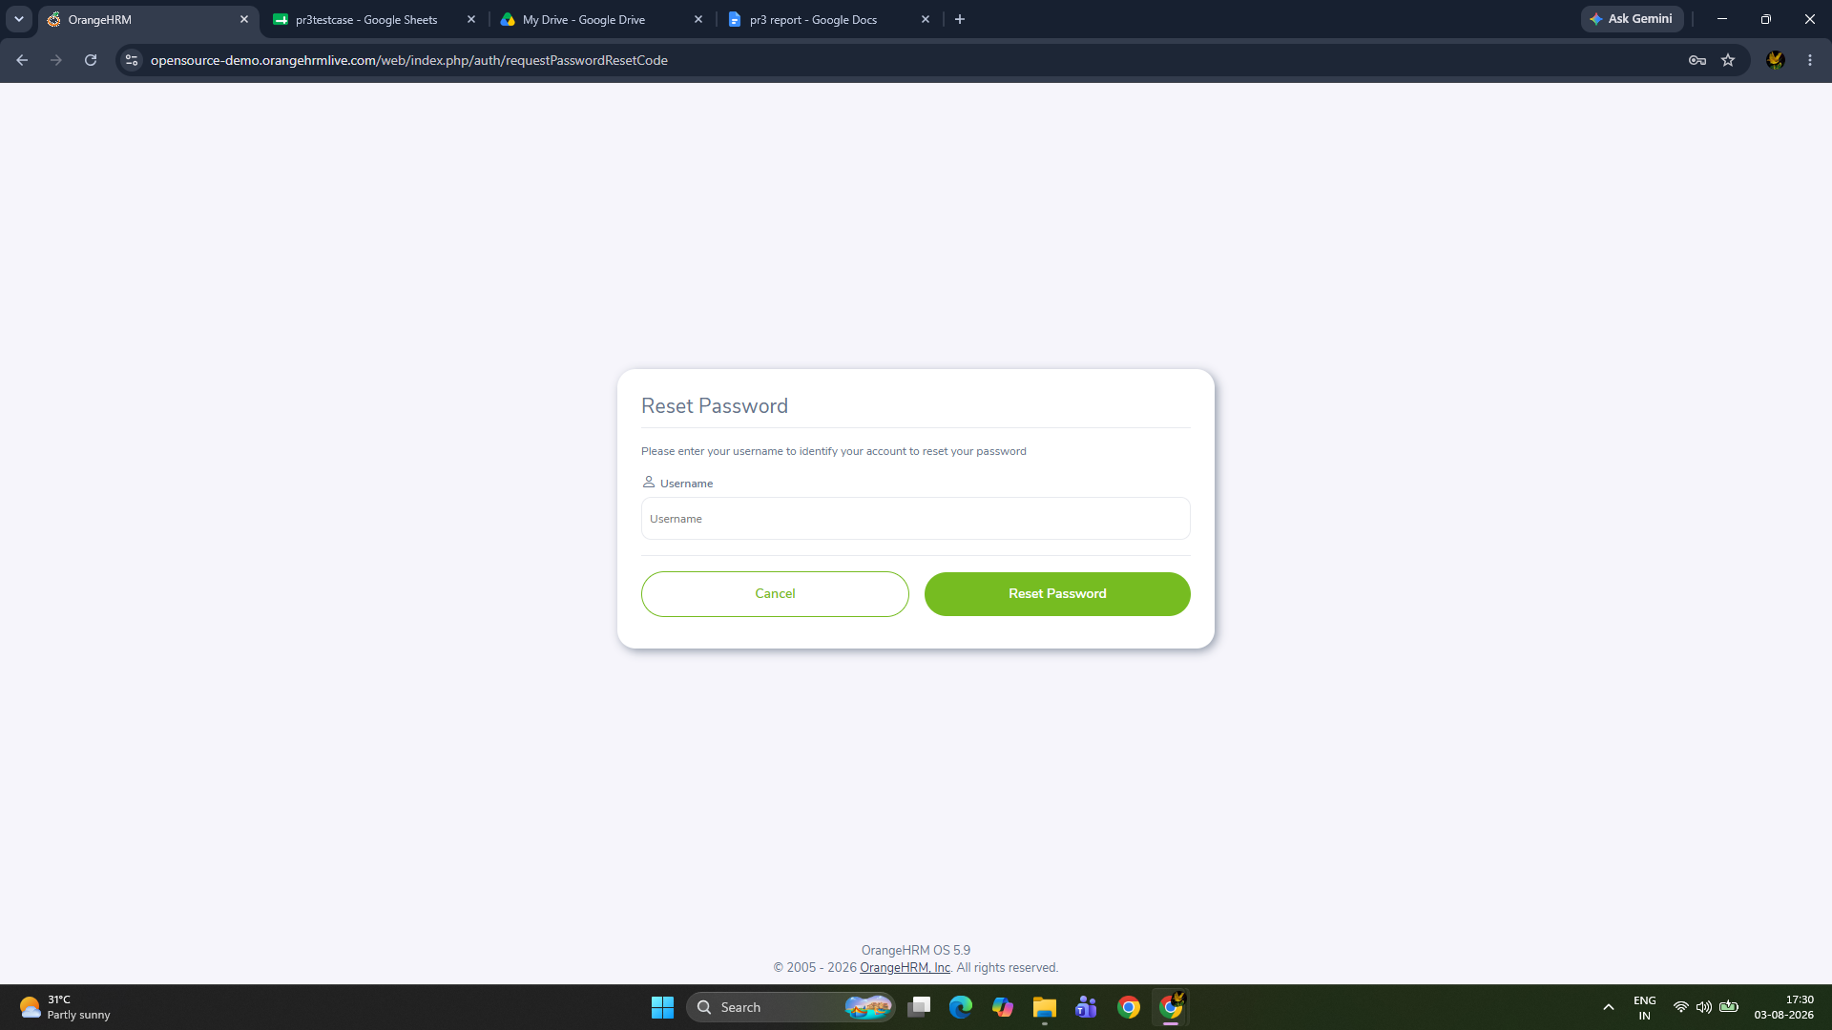
SCENAERIO 07 : VERIFY LOGOUT
TEST IID : TC_007
TEST STEPS: PROFILE > LOGOUT

SCENARIO 08 : VERIFY PAGE REFRESH
TEST IID : TC_008
TEST STEPS: RELOAD THE PAGE AFTER LOGIN

